**Ajay Kumar Garg Engineering College, Ghaziabad**

**Central Library**

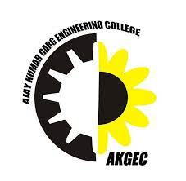

**Estd.1998**

**4.2.2: The institution has subscription for e-resources**

**(Additional Information)**

2016-17



**Estd.1998**

**Summary& Payment Receipt of E-Resources:-**

1. E-Journal
2. E-Books
3. Database
4. Remort Access to E-resource

**SUBSCRIBED E-JOURNALS/RESOURCES IN YEAR 2016**

|  |  |  |  |
| --- | --- | --- | --- |
| **S. No.** | **Publication** | **Subject Areas** | **Access** |
|  | IEEE (ASPP) | CS+EC+EN & Telecommunication | 169 E-Journals (Back File Access Since 2000) |
|  | Springer | EN +EC+CS | 149E-Journals (Back File Access Since 1997) |
|  | ASME | ME | 29E-Journals (Back File Access Since 2000) |
|  | Mc Graw Hill | e-Books for General Engineering Reference | 380 E-books (Contents Related to all Engineering Branch) |
|  | J-Gate Engineering | E-journals of All Engg. Branches | 116447 Full text free Database, 81457 Indexed database |
|  | Elsevier (Science Direct) | CS+EN+EC+IT+Sy. Engg. + back files since 2000. | 275 E-Journals (Back File Access Since 2000) |
|  | ASTM Digital Library Online | EN+EC+Civil+ ME (e-books & e-journals) | 8 E-Journals, 1700 E-Books and 13000 Journals Articles |
|  | ASCE | Civil Engineering | 38 E-Journals (Back File Access Since 2000) |
|  | **Total** |  | **668 e-journals + 380 e-books + 197904 database** |

Screen Shot of payment of e-resources for the above are as follows:























**Ajay Kumar Garg Engineering College, Ghaziabad**

**Central Library**



**Estd.1998**

**4.2.2: The institution has subscription for e-resources**

**(Additional Information)**

2017-18



**Estd.1998**

**Summary& Payment Receipt of E-Resources:-**

1. E-Journal
2. E-Books
3. Database

Remort Access to E-resource

**SUBSCRIBED E-JOURNALS/RESOURCES IN YEAR 2017**

**E-Journals:**

|  |  |  |  |
| --- | --- | --- | --- |
| **S. No.** | **Publication** | **Subject Areas** | **Access** |
|  | IEEE All-Society Periodicals Package (ASPP) | CS+EC+EN & Telecommunication | 169 E-Journals (Back File Access Since 2000) |
|  | Springer | EN +EC+CS | 149E-Journals (Back File Access Since 1997) |
|  | ASME | ME | 28E-Journals (Back File Access Since 2000) |
|  | ASCE | Civil Engineering | 36 E-Journals (Back File Access Since 1983) |
|  | Mc Graw Hill | e-Books for General Engineering Reference | 380Contents Related to all Engineering Branch |
|  | ELSEVIER (AICTE Science Direct Engineering + CS) | CS+EN+EC+IT+Sy. Engg. + back files since 2000. | 275 E-Journals (Back File Access Since 2000) |
|  | ASTM Digital Library Online | EN+EC+Civil+ ME (e-books & e-journals) | 8 E-Journals, 1700 E-Books and 13000 Journals Articles |
|  | J-Gate Engineering | E-journals of All Engg. Branches | 7035 Full text free E-journals, 4700 Indexed |
|  | DELNET | General Engineering & Reference | Union List of Current Periodicals – 37,847 |
|  | ISO | ISO JTC 1, Information Technology, Electronics & Telecommunications | 3021 published ISO Standards |
|  | AICTE –IET Journals | General Engineering & Reference | 150,000 peer-reviewed articles in a wide range of journals |
|  | National Digital Library | General Engineering & Reference | 3 lakh Articles by more then 2 lakhs author form different publishers |
|  |  | **Total** | **622 e-journals + 380 e-books + 187847 database** |

Screen Shot of payment of e-resources for the above are as follows:

















































**Ajay Kumar Garg Engineering College, Ghaziabad**

**Central Library**



**Estd.1998**

**4.2.2: The institution has subscription for e-resources**

**(Additional Information)**

2018-19



**Estd.1998**

**Summary& Payment Receipt of E-Resources:-**

1. E-Journal
2. E-Books
3. Database
4. Remort Access to E-resource

**SUBSCRIBED E-JOURNALS/RESOURCES IN YEAR 2018**

**E-Journals:**

|  |  |  |  |
| --- | --- | --- | --- |
| **S. No.** | **Publication** | **Subject Areas** | **Access** |
|  | IEEE All-Society Periodicals Package (ASPP) | CS+EC+EN & Telecommunication | 169 E-Journals (Back File Access Since 2000) |
|  | Springer | EN +EC+CS | 149E-Journals (Back File Access Since 1997) |
|  | ASME | ME | 28E-Journals (Back File Access Since 2000) |
|  | ELSEVIER (AICTE Science Direct Engineering + CS) | CS+EN+EC+IT+Sy. Engg. + back files since 2000. | 314 E-Journals (Back File Access Since 2000) |
|  | DELNET | General Engineering & Reference | Union List of Current Periodicals – 37,847 |
|  | AICTE-IET Journals | General Engineering & Reference | 150,000 peer-reviewed articles in a wide range of journals |
|  | World e-Bbook Library | All Subject e-Books | About 4 million e-Books covering all subjects and includes 2,62,014 Engineering titles |
|  | National Digital Library | General Engineering & Reference | 3 lakh Articles by more then 2 lakhs author form different publishers |
|  |  | **Total** | **660 e-journals + 2,62,014 e-books + 2,79,30,550 database** |

Screen Shot of payment of e-resources for the above are as follows:

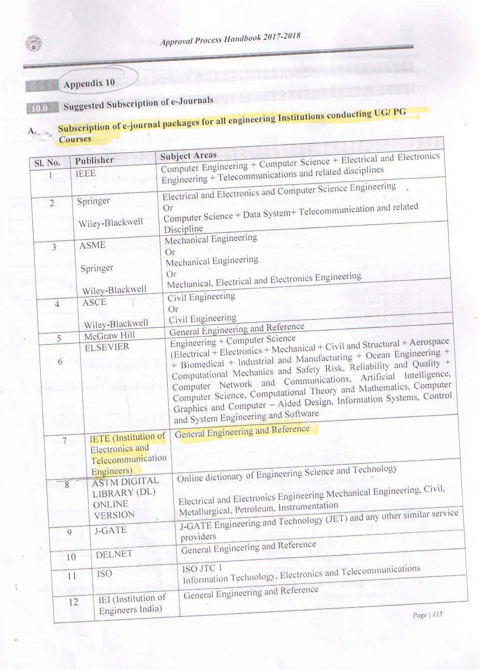















**Ajay Kumar Garg Engineering College, Ghaziabad**

**Central Library**



**Estd.1998**

**4.2.2: The institution has subscription for e-resources**

**(Additional Information)**

2019-20



**Estd.1998**

**Summary& Payment Receipt of E-Resources:-**

1. E-Journal
2. E-Books
3. Database
4. Remort Access to E-resource

**SUBSCRIBED E-JOURNALS/RESOURCES IN YEAR 2019**

**E-Journals:**

|  |  |  |  |
| --- | --- | --- | --- |
| **S. No.** | **Publication** | **Subject Areas** | **Access** |
|  | IEEE All-Society Periodicals Package (ASPP) | CS+EC+EN & Telecommunication | 169 E-Journals (Back File Access Since 2000) |
|  | Springer | EN +EC+CS | 149E-Journals (Back File Access Since 1997) |
|  | ASME | ME | 28E-Journals (Back File Access Since 2000) |
|  | AICTE-IET Journals | General Engineering & Reference | 150,000 peer-reviewed articles in a wide range of journals |
|  | ELSEVIER (AICTE Science Direct Engineering + CS) | CS+EN+EC+IT+Sy. Engg. + back files since 2000. | 314 E-Journals (Back File Access Since 2000) |
|  | DELNET | General Engineering & Reference | Union List of Current Periodicals – 37,847 |
|  | World e-Bbook Library | All Subject e-Books | About 4 million e-Books covering all subjects and includes 2,62,014 Engineering titles |
|  | National Digital Library | General Engineering & Reference | 3 lakh Articles by more then 2 lakhs author form different publishers |
|  |  | **Total** | **660 e-journals + 2,62,014 e-books + 2,79,30,550 database** |

Screen Shot of payment of e-resources for the above are as follows:

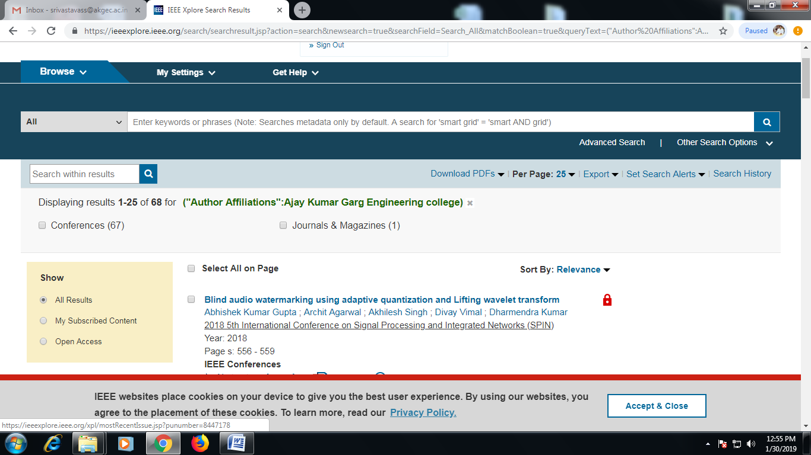

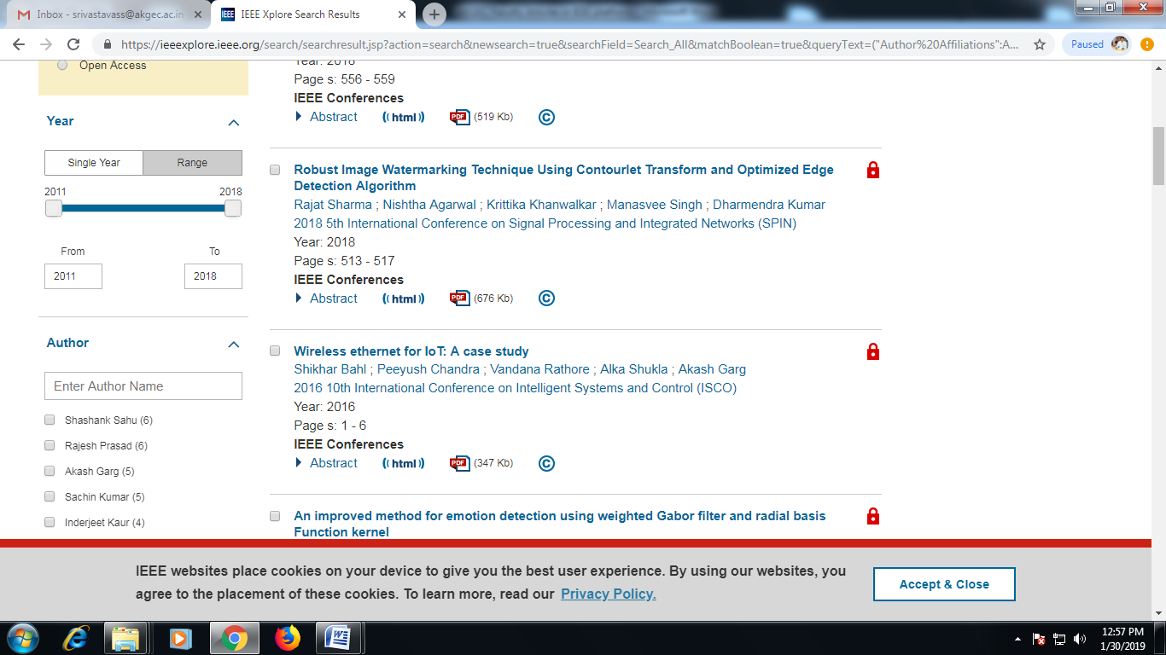

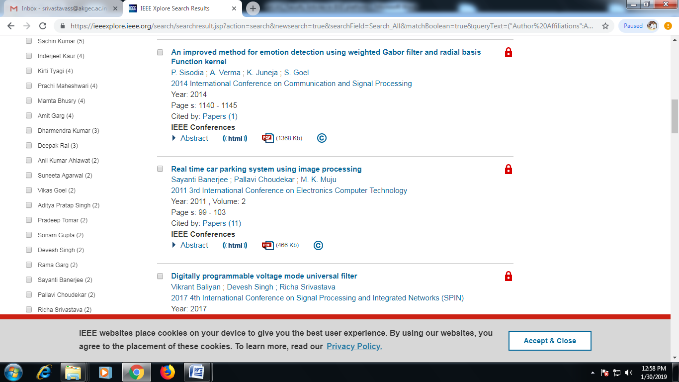

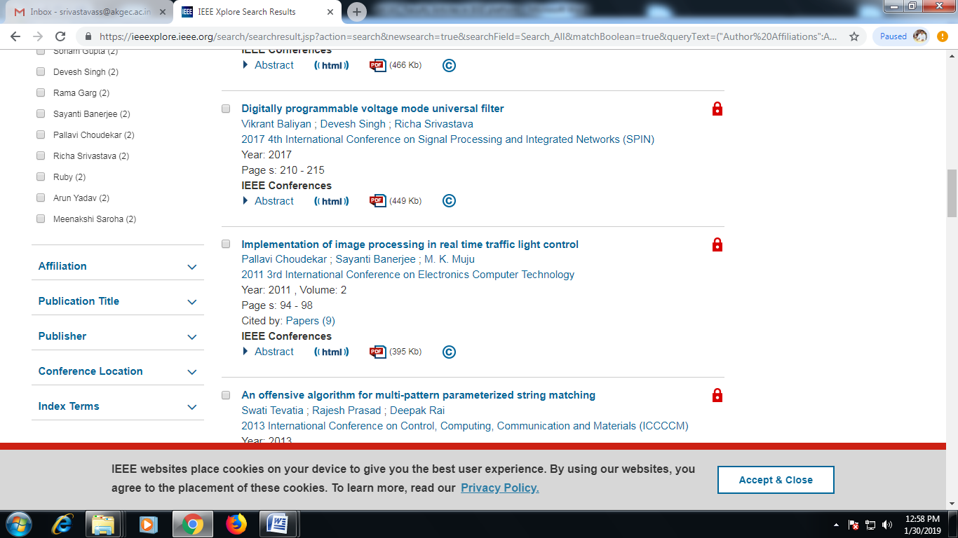



IEEE

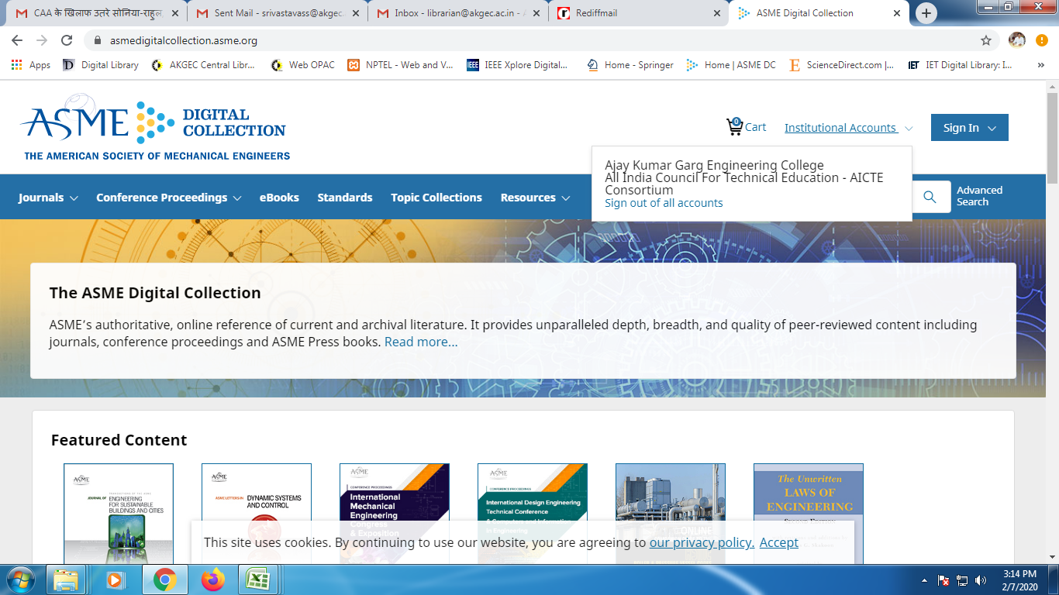

**ASME**

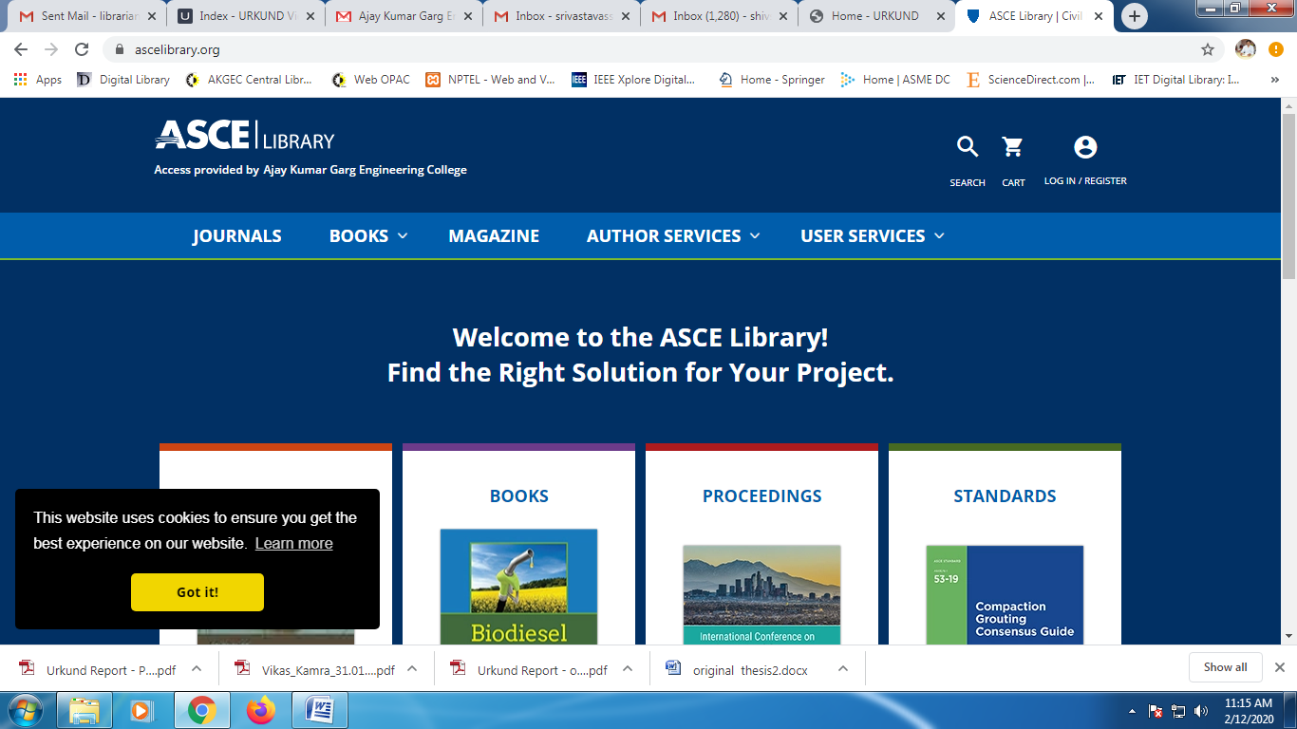

ASCE

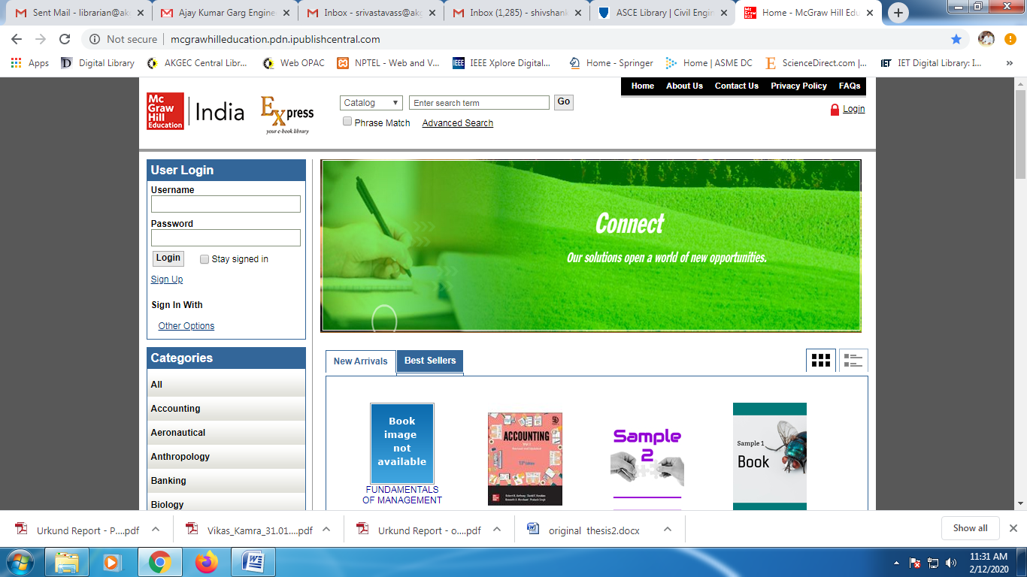

Mc Graw Hill



Science Direct



JSTOR

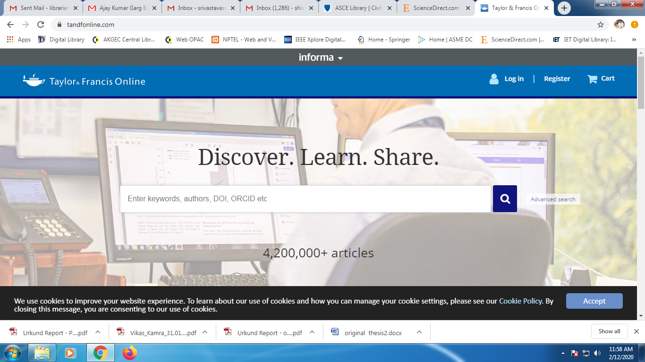

Taylar & Francis

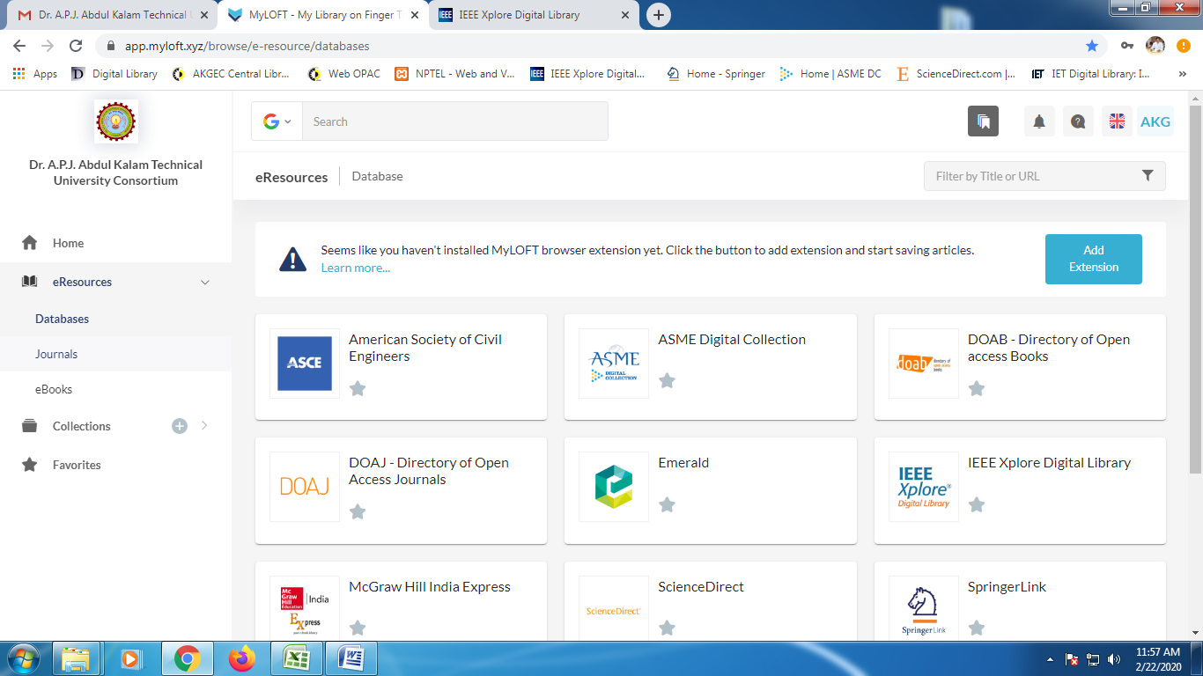

Myloft Access





Proof of Payment of AKTU Consortium

**Ajay Kumar Garg Engineering College, Ghaziabad**

**Central Library**



**Estd.1998**

**4.2.2: The institution has subscription for e-resources**

**(Additional Information)**

2020-21



**Estd.1998**

**Summary& Payment Receipt of E-Resources:-**

1. E-Journal
2. E-Books
3. Database
4. Remort Access to E-resource

**SUBSCRIBED E-JOURNALS/RESOURCES IN YEAR 2020**

**E-Journals:s**

|  |  |  |  |
| --- | --- | --- | --- |
| **S. No.** | **Publication** | **Subject Areas** | **Access** |
|  | IEEE Xplore Digital Library | CS+EC+EN & Telecommunication | 56 E-Journals (Back File Access Since 2000) |
|  | ASME | ME | 34E-Journals (Back File Access Since 2000) |
|  | ASCE | Civil Engineering | 39 E-Journals (Back File Access Since 1983) |
|  | Mc Graw Hill | e-Books for General Engineering Reference | 159 e-Books |
|  | Science Direct (Elsevier) | CS+EN+EC+IT+Sy. Engg. + back files since 2000. | 296 E-Journals (Back File Access Since 2000) |
|  | JSTOR | Journals, e-Books for General Engineering | 3,300 Journals and 71,000 e-books |
|  | Taylar & Francis | Engineering and Technology Journals | 578 e-Journals (www.tandfornline.com) |
| E-books | 6000 e-Books (www.taylarfrancis.com) |
|  | DELNET | General Engineering & Reference | Union List of Current Database – 37,847 |
|  | National Digital Library | General Engineering & Reference | 3 lakh Articles by more then 2 lakhs author form different publishers |
|  | MyLOFT – My Library on Fingertips | Discovering Library Networks for resource sharing |  |
|  |  | **Total** | **4303 Journals + 77,159 E-books + 37,847 Database** |

Screen Shot of payment of e-resources for the above are as follows:











IEEE



**ASME**



ASCE



Mc Graw Hill



Science Direct



JSTOR



Taylar & Francis



Myloft Access



Proof of Payment of AKTU Consortium



Proof of Payment of AKTU Consortium